Fieldwork - Marrickville
Field sketch

Draw two different field sketches of Marrickville – one that shows evidence of the heritage of the suburb and one that shows evidence of change taking place (this might be more modern architecture, high density housing, etc.). Ensure that you annotate your field sketches.
Field sketch 1:

Field sketch 2:

Environmental survey

Examine the following environmental criteria and make a judgement about the main street of Marrickville. This is a subjective task and requires you to make a judgement about what you think of the location and how it makes you feel. For each item you need to give a rating from 1 to 5 (tick the box).
 | 1 | 2 | 3 | 4 | 5
Ugly |  |  |  |  |  | Beautiful
Smelly |  |  |  |  |  | Fresh
Chaotic |  |  |  |  |  | Ordered
Unhealthy |  |  |  |  |  | Healthy
Motionless |  |  |  |  |  | Moving
Poor |  |  |  |  |  | Rich
Boring |  |  |  |  |  | Interesting
Old |  |  |  |  |  | New
Weak |  |  |  |  |  | Strong
Noisy |  |  |  |  |  | Quiet
Hostile |  |  |  |  |  | Friendly
Dirty |  |  |  |  |  | Clean
Empty |  |  |  |  |  | Dense
Dark |  |  |  |  |  | Light
Tense |  |  |  |  |  | Relaxed
Pessimistic |  |  |  |  |  | Optimistic
Multicultural |  |  |  |  |  | Mono-cultural
Alternative |  |  |  |  |  | Mainstream
Unsafe |  |  |  |  |  | Safe
Monotonous |  |  |  |  |  | Colourful

Photographic evidence

During the day, take photographs that demonstrate:

- Marrickville’s heritage
- Multiculturalism
- Marrickville’s industrial landuse
- Marrickville’s artistic scene
- Marrickville’s alternate culture
- Marrickville’s café culture/pub scene

Land use survey

As you walk along the streets annotate your map indicating which land uses are present. Before you begin, fill in the key below with colours or symbols to represent each land use.
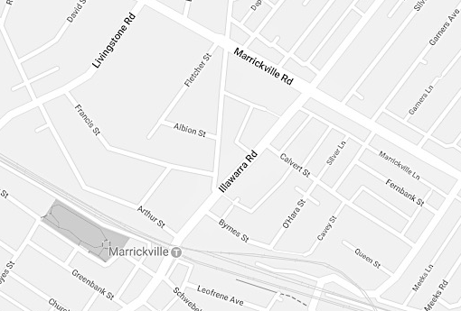

☐ Residential – low density
☐ Residential – medium/high density
☐ Commercial
☐ Industrial
☐ Recreational
☐ Agricultural
☐ Mixed use
☐ Transportation/Utilities

Reflection:
Describe how the different land uses are represented in discrete zones in the suburb of Marrickville.
………………………………………………………………………………………………………………………………………………………………………………………………………………………………………………………………………………………………………………………………………………………………………………………………………………

Explain why the commercial and industrial land uses are concentrated in particular areas.
………………………………………………………………………………………………………………………………………………………………………………………………………………………………………………………………………………………………………………………………………………………………………………………………………………

Questionnaire

- Do you live/work in Marrickville?
Yes No

- If you live/work in Marrickville, how long have you lived/worked here?
0-5 yrs 6-10 yrs 11-15 yrs 16-20 yrs 20+ yrs

- What attracted you move into/visit Marrickville? (You can tick more than one).
Multiculturalism – food, people, etc Café Culture/Pub scene
Affordable housing Alternate culture
Heritage architecture and streetscapes Artistic scene
Industrial jobs/Factories Café Culture
Other
Please specify …………………………………………………………………………………………………………………………………..

- There are currently plans proposed to radically change the nature of Marrickville through increased density. What do you think will be the benefits of this?
…………………………………………………………………………………………………………………………………..
…………………………………………………………………………………………………………………………………..
- What will be the negative impacts of this (refer to previous question)?
…………………………………………………………………………………………………………………………………..
…………………………………………………………………………………………………………………………………..
- How do you feel about proposed changes to increase the density of Marrickville?
Strongly oppose Oppose Neutral Support Strongly support

- How do you feel about the proposed decrease in industrial land and increase in artistic/creative space in Marrickville?
Strongly oppose Oppose Neutral Support Strongly support

- Have you attended any public meetings or council meetings about the proposals to change Marrickville?
Yes No

- Have you attended any rallies, participated in any email or social media campaigns about this issue?
Yes No

